**Assignment -2**

Working with DB2

|  |  |
| --- | --- |
| Student Name | Mr. Thavamuthubaskaran L |
| Student Roll Number | 711319CS170 |

**Question-1:**

Create User table with user with email, username, roll number, password.

|  |
| --- |
| **Solution:** |
|  | CREATE TABLE USER( |
|  | USER_ID INT GENERATED BY DEFAULT AS IDENTITY NOT NULL, |
|  | EMAIL_ID VARCHAR(150) NOT NULL, |
|  | USER_NAME VARCHAR(255) NOT NULL, |
|  | ROLL_NUMBER VARCHAR(100) NOT NULL, |
|  | PASSWORD VARCHAR(100) NOT NULL, |
|  | PRIMARY KEY (USER_ID) |
|  | );  INSERT INTO USER(EMAIL_ID, USER_NAME,ROLL_NUMBER,PASSWORD)  VALUES('rk9166771@gmail.com','Rajeshkumar S','19CS123','9787234640');  INSERT INTO USER(EMAIL_ID, USER_NAME,ROLL_NUMBER,PASSWORD)  VALUES('ramachandramoorthykb@gmail.com','Ramachandramoorthy K B','19CS124','9912346578'); |
|  |  |

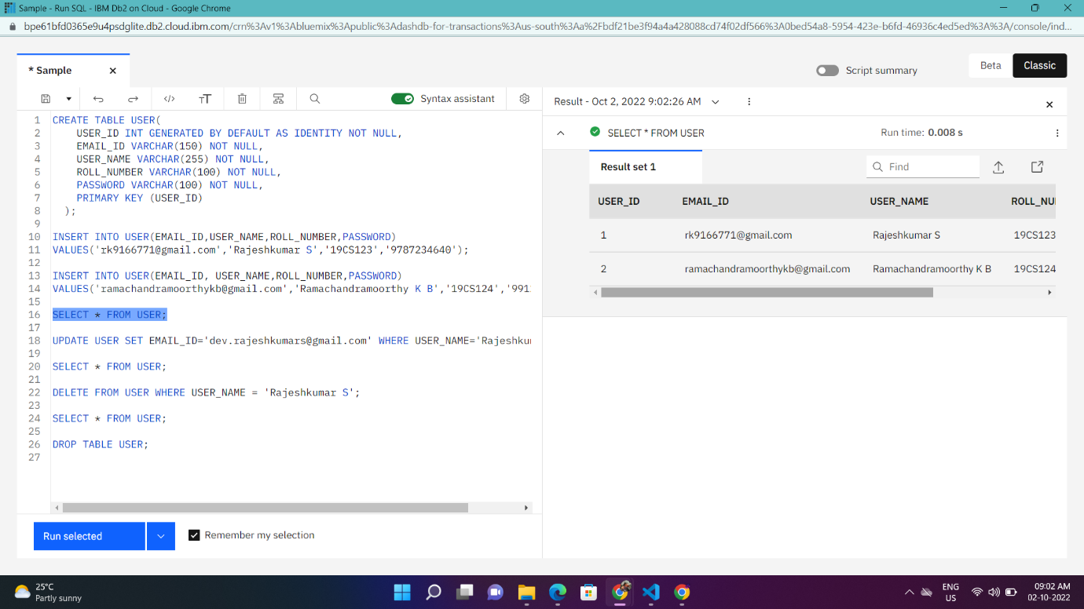

**Question-2:**

Perform UPDATE, DELETE Queries with user table

**UPDATE:**

**Solution:**

UPDATE USER SET EMAIL_ID='dev.rajeshkumars@gmail.com' WHERE USER_NAME='Rajeshkumar S';

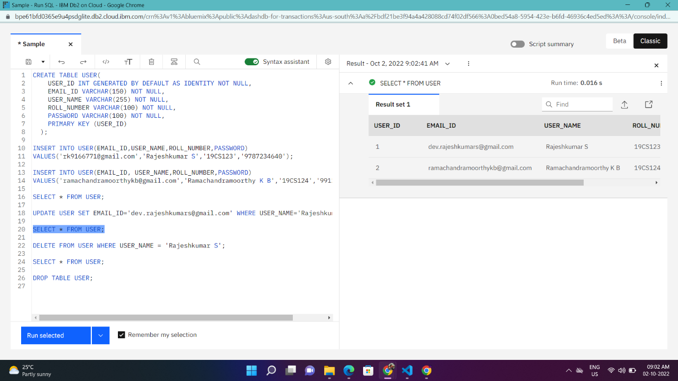

**DELETE:**

|  |
| --- |
| **Solution:** |
|  | DELETE FROM USER WHERE USER_NAME = 'Rajeshkumar S'; |

